L2P Drive With Me  l2p.today  e: drive@l2p.today // help@feedmorepeople.org  m: 0404 178 126  Global Community Support t/a Feed More People and t/a L2P Drive With Me is a registered charity with DGR status. ABN 89600810348 | 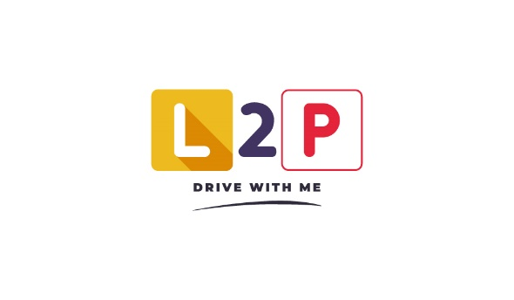

L2P Drive With Me - Refund Policy
- Overview:
  - Global Community Support t/a Feed More People and t/a L2P Drive With Me is a registered charity with DGR status ABN 89600810348.
  - Donations made are tax deductible in keeping with ACNC regulations relative to charities with DGR status. For more information, please visit www.acnc.gov.au .
  - In any circumstance where a refund is requested, you must have a copy of the original receipt from the time of session purchase or donation, etc. If you do not have a receipt copy, you will be ineligible for a refund.
    - If you do not receive a receipt within 24 hours of any session purchase or donation, please immediately contact refund@l2p.today .
- Refund Requests with regard to donations.
  - Donations made to the charity L2P Drive With Me are non-refundable after a period of 24 hours from receipt sending. If you wish to make a refund request within the 24 hour window, please email our accounts team at refund@l2p.today .
  - In the instance of a recurring donation, you will receive a notification 24 hours in advance of the automatic transaction.
- Refund Requests with regard to purchased sessions
  - During the application for driving sessions with L2P Drive With Me, payment will be requested as per the fees mentioned to maintain running costs for the charity L2P Drive With Me. Upon completing the application, you acknowledge that you will be available for the full set of ten (10) sessions across a time period of your choice.
  - From the completion of your application, you will have ninety (90) days to lodge a refund request. After this time has elapsed, or upon commencement of your first driving session, the opportunity to refund part or all of the session package is voided.
- Refund Requests with regard to charity promotions and campaigns
  - In the event of a charity promotion refunds will not be offered. This applies to:
    - Raffles and similar fundraising games/events
    - Public events hosted by L2P that have an admission fee

