L2P Drive With Me  l2p.today  e: drive@l2p.today // help@feedmorepeople.org  m: 0404 178 126  Global Community Support t/a Feed More People and t/a L2P Drive With Me is a registered charity with DGR status. ABN 89600810348 | 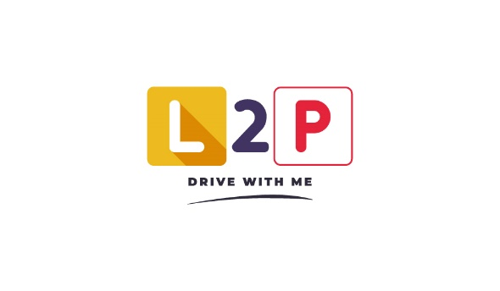

L2P Drive With Me - Terms and Conditions

General
- By accessing this site, you acknowledge that you have read and agree to abide by the policies and rules as set out in the Privacy Policy.
- By entering into a financial exchange of any kind with L2P Drive With Me, including but not limited to donations, sponsorships or purchasing of sessions, you agree to the policies and rules as set out in the Refund Policy.

For Learners
Requirements:
- Have completed at least 5 hours in your Learner Permit Logbook prior to enrolling.
- Be willing to commit to 10, 2 hour sessions with a driving mentor with at least one session every two weeks.
- Attend a maximum of 2 blocks of 10 sessions (40hr total) with L2P to allow access to as many learners as possible.
- Attend sessions at the car dealership to learn about car maintenance, servicing, washing and how to change a tyre.
- Experience a range of increasingly dynamic road journeys as your confidence and experience grows.
- Sit your driving licence test upon accruing the necessary hours.
- Consider buying, or organising a micro loan for, your own car which L2P will assist you with. L2P’s help doesn’t stop once you’ve left the car.
- Build your confidence.
- During mentoring sessions, you agree to:
  - Abide by all motor vehicle laws, both while the vehicle is in motion and stationary.
  - Check in to the vehicle as a location using the mySA application for every session.
    - Alternatively, I will supply L2P with the relevant information for a manual check-in using a form that will be present in the vehicle.

For Mentors
- We are looking for mentors of all ages to help the young learner drivers of Adelaide to fill their logbook and be able to apply for their full license. All applicants will be duly considered with no prejudice given to age, race, religious beliefs, sexual orientation, or political views.
- All mentors will be thoroughly screened, driver tested, trained, police checked, covid-safe cleaning educated, and committed to people getting their drivers license and all the freedom that provides.
- During mentoring sessions, you agree to:
  - Ensure that the student abides by all motor vehicle laws, both while the vehicle is in motion and stationary.
  - Check in to the vehicle as a location using the mySA application for every session.
    - Alternatively, supplying L2P with the relevant information for a manual check-in using a form that will be present in the vehicle.
  - Confirm session commencement and conclusion using the L2P form on the supplied mobile device.

For Sponsors and Donors
- I understand that any donations made are subject to the rules and regulations of the ACNC, under which L2P Drive With Me has DGR status. For more information, visit www.acnc.gov.au

