L2P Drive With Me  l2p.today  e: drive@l2p.today // help@feedmorepeople.org  m: 0404 178 126  Global Community Support t/a Feed More People and t/a L2P Drive With Me is a registered charity with DGR status. ABN 89600810348 | 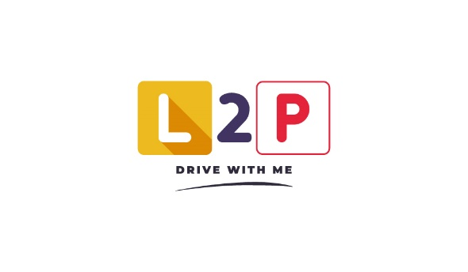
L2P Drive With Me - Privacy Policy
- Personal information
  - You should read this policy before providing us with any personal information or before using our website. By providing us with your personal information or by using the website, you are confirming your agreement to the policies and procedures described in this policy. From time to time it may be necessary for us to review and revise this policy. We reserve the right to change this policy at any time.
- Our organisation
  - Global Community Support t/a Feed More People and t/a L2P Drive With Me is a registered charity with DGR status. As such any information provided will be stored and used exclusively within the restrictions set out by the Privacy Act 1988.
- Information that we collect and hold
  - For as long as the person wishes to remain in communication with us:
    - Item 20W: Retention period for credit information - general
    - Item 20X: Retention period for credit information- personal insolvency information
  - Customers:
    - General information such as full name, date of birth,
    - Drivers license information
    - Payment information
    - Contact details: Phone number or email address
  - Personnel (mentors, staff):
    - General information such as full name, date of birth,
    - Drivers license information
    - Banking details
    - Contact details: Phone number or email address
  - Sponsors/Other
    - General information such as full name, date of birth,
    - Drivers license information
    - Banking details
    - Contact details: Phone number or email address
    - Amount donated
    - Proof of payment/receipt as required by ATO and ACNC
- How we collect your information
  - Online forms through the L2P website and apps, including those accessed through a QR code, from links in promotional methods such as social media, email marketing..
  - In-person events, such as presentations or demonstrations hosted by L2P staff.
  - Physical sign-in for staff and students upon commencement and/or completion of a session.
    - Phone/web based login for mentoring shifts, attending driving sessions and attendance at events where log book information is required.
- Why we collect, hold and use personal information
  - Providing receipts to donors
  - Maintaining communications with students
  - Maintaining communications with mentors
  - Payment for staff
  - Sharing your information
  - We will only share your information if required by legal groups such as emergency services, driving schools etc.
    - IT service providers, legal service providers, mailing houses, call centres, other community service providers
    - Any cases of self harm, mental health issues, domestic violence or similar cases where a stakeholder may be in danger.
    - Any cases where the customer is seen to be a danger to themself or others and requires referral for more instruction by a trained driving school.
- Google marketing // Website statistics //Analytics
  - All our data will be ethically analysed to find ways to best serve more customers.
  - We may track data like:
    - Number of visits to a page from a certain IP address
    - Number of page hits
    - Pages accessed or downloaded by session
    - Browser being used
    - Length of time spent on pages
    - Device being used (desktop/mobile)
    - Mobile device being used, if relevant
- Seeking correction of your personal information
  - If you seek to request an update or change to your personal information, your identity will first be verified and we will update our records accordingly. Please contact our administration on drive@l2p.today or call on 0404 178 126.
  - If you believe we are in breach with the Australian Privacy Principles set out in the Privacy Act 1988, contact us and we will make every endeavour to address your concerns.
- Compliance with notifiable Data Breaches Scheme
  - We will notify you in the event your personal information is involved in a data breach that is likely to result in serious harm. This notification will include recommendations about the steps you should take in response to the breach. We will also notify The Australian Information Commissioner of eligible data breaches. Each suspected data breach reported to us will be assessed to determine whether it is likely to result in serious harm, and as a result require notification.

